Neville Baker Memorial Stableford – 29 August 2026
Winner over the field was Dave Hodges with 39 stablefords, by lot over Frozzie Bennett
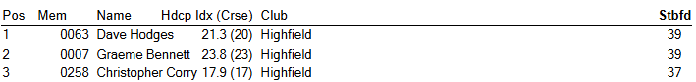
4 Sam McLauglan 37
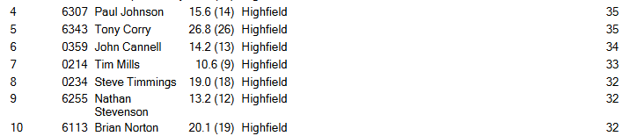
10 Jordan Kaplin 32
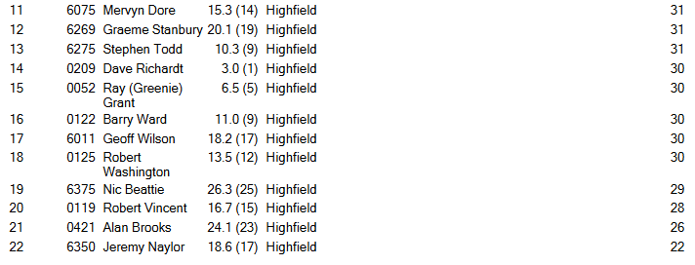
Other Results 29 August 2026
RSM Best Gross – Dave Richardt Net Eagle – Steve Todd
Net Birdies – Steve Todd Twos not Struck Closest to Pin – Nick Beattie

Breen Plumbing 9 Holes
