Timaru Construction Stableford – 3 January 2026
Winner over the field on Saturday with 42 stablefords was Scott Gillies
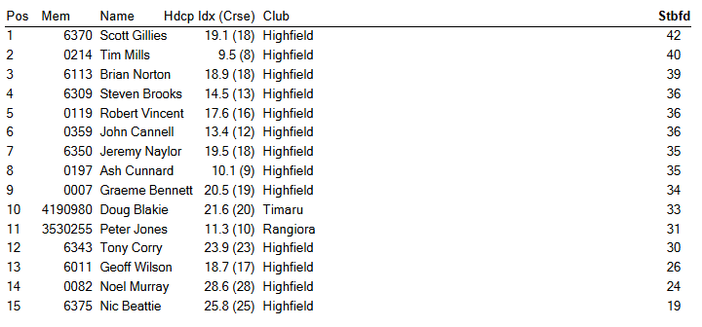
Other Results 3 January 2026
RSM Best Gross – Tim Mills
Net Eagle – Jeremy Naylor Net Birdies – Jeremy Naylor
Twos – Stevn Brooks, Robert Vincent, Ash Cunnard Closest to Pin – Ash Cunnard

Breen Plumbing 9 Holes – not played due to weather
