4BBB Stableford – 29 November 2025
Club Champ Winners 2025 – Simon Cunnard – Seniors, Nathan Mason – Intermediate, Jeremy Naylor – Juniors, Arthur Dawes – Limit
Winner over the field on Saturday with 44 Stablefords was Phil Buckle & Mapu Tanu (by lot).
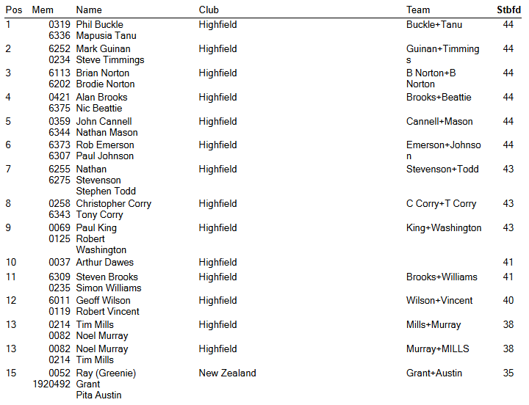
Other Results 29 November 2025
RSM Best Gross – Steve Todd, Nathan Mason
Net Eagle – PJ Johnson Net Birdies – Steve Brooks
Twos – Geoff Wilson Closest to Pin – Simon Williams
Timaru Construction 9 Holes
