Captains Choice Stableford – 20 December 2025
Winner over the field on Saturday with 42 Stablefords was Rusty Corry
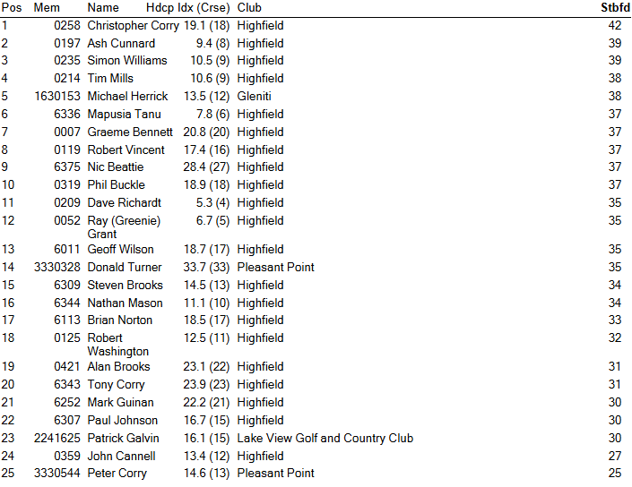
Other Results 20 December 2025
RSM Best Gross – Dave Richardt, Mapu Tanu & Ash Cunnard
Net Eagle – Nic Beattie Net Birdies – Ash Cunnard
Twos – Greenie Grant, Brian Norton Closest to Pin – Nathan Mason

Breen Plumbing 9 Holes
