RSM Stableford – 22 November 2025
Winner over the field on Saturday with 44 Stablefords was Nic Beattie.
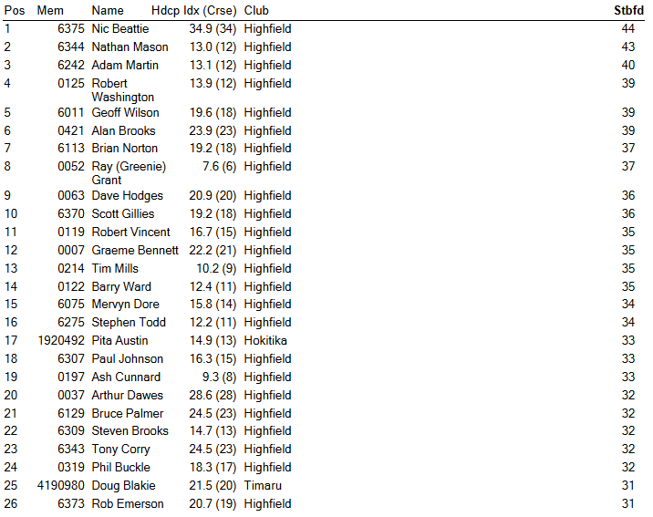
Other Results 22 November 2025
RSM Best Gross – Greenie Grant, Nathan Mason
Other Net Eagle – Nic Beattie Net Birdies – Rob Washington
Twos – Nathan Mason, Allan Brooks Closest to Pin – Pita Austin
Timaru Construction 9 Holes
